DISCOVERAD LABORATORY TESTSHEET

REFERENCES
PRODUCT NAME |  |  |  |  |  | DiscoveRAD
PRODUCT CODE |  |  |  |  |  | WSRAD501AAAA
SOFTWARE VERSION |  |  |  |  |  | 12345
PRODUCT IDENTIFICATION |  |  |  |  |  | CAEN PID S/N
 |  |  |  |  |  | 21470
INDEX OF PERFORMED TESTS
COMPONENTS CHECKLIST |  |  |  |  |  |  |  |  |  |  |  | PASSED
FUNCTIONAL TESTS |  |  |  |  |  |  |  |  |  |  |  | PASSED
IDENTIFICATION TEST |  |  |  |  |  |  |  |  |  |  |  | PASSED
AMBIENT DOSE EQUIVALENT |  |  |  |  |  |  |  |  |  |  |  | PASSED
DOSE RATE TEST |  |  |  |  |  |  |  |  |  |  |  | PASSED
NEUTRON STATIC TEST |  |  |  |  |  |  |  |  |  |  |  | PASSED
DATE |  |  |  |  |  |  |  |  |  | SITE
7/24/2025 |  |  |  |  |  |  |  |  |  | CAEN SyS Laboratory
SIGNATURE
Test department operator

Simone Ciurli



COMPONENTS CHECKLIST
ITEM |  | OUTCOME |  |  |  |  |  | ITEM |  |  |  |  | OUTCOME
WRIST LANYARD |  |  |  |  |  |  |  | AC/DC PLUG |  |  |  |  | 
BELT HOLSTER |  |  |  |  |  |  |  | MANUAL |  |  |  |  | 
2x USB CABLES |  | 
Battery 1 PID |  | OUTCOME |  |  |  |  |  | Battery 2 PID |  |  |  |  | OUTCOME
12345 |  |  |  |  |  |  |  | 67890 |  |  |  |  | 

FUNCTIONAL TESTS
SPECTRUM STABILIZATION |  |  |  | 
FINDER MODE |  |  |  | 
- VISUAL ALARM |  |  |  | 
- AUDIO ALARM |  |  |  | 
- VIBRATION ALARM |  |  |  | 
CALIBRATION CHECK |  |  |  | 
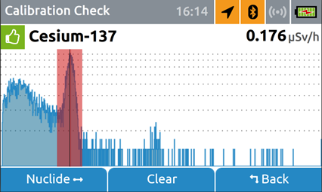

EASY FINDER MODE |  |  |  | 
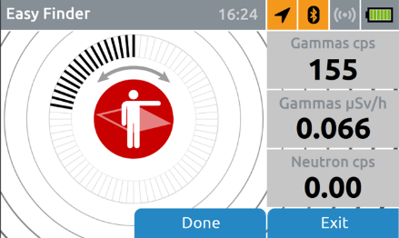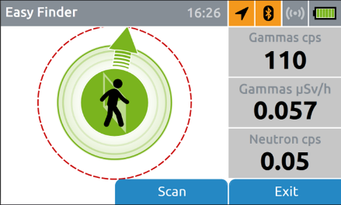

WI-FI CONNECTION |  |  |  | 
WEB INTERFACE |  |  |  | 

IDENTIFICATION TEST
SOURCE |  |  | ACTIVITY |  |  |  |  |  | REF. DATE |  |  |  |  | DISTANCE (cm)
Cs-137 |  |  | 327.90 kBq |  |  |  |  |  | 24/7/2025 |  |  |  |  | 30
Am-241 |  |  | 409.90 kBq |  |  |  |  |  | 24/7/2025 |  |  |  |  | 35
Co-60 |  |  | 7.44 kBq |  |  |  |  |  | 24/7/2025 |  |  |  |  | 5
NOTE |  |  |  |  |  | Am-241, Cs-137 and Co-60 sources are positioned to trigger a gamma alarm
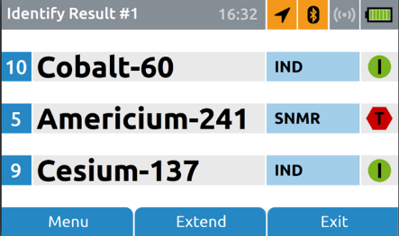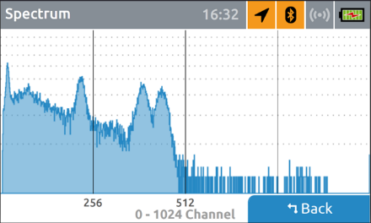

AMBIENT DOSE EQUIVALENT H*(10) TEST
NOTE |  |  |  |  |  | After the warm-up of the system, with no sources around, check the average dose rate
BACKGROUND DOSE RATE (µSv/h*) |  |  |  |  |  | 0.042
SOURCE |  |  |  |  | ACTIVITY |  |  |  |  |  | REF. DATE
Cs-137 |  |  |  |  | 9 MBq |  |  |  |  |  | 18/07/2022
DISTANCE (cm) | MEASURED AMBIENT DOSE - BKG (µSv/h*) |  |  |  |  |  | ACCEPTABLE AMBIENT DOSE RANGE (µSv/h*)  (MIN – MAX) |  |  |  |  |  |  |  | OUTCOME
30 | 0.724 |  |  |  |  |  | 0.194 – 0.361 |  |  |  |  |  |  |  | O
50 | 0.248 |  |  |  |  |  | 0.070 – 0.130 |  |  |  |  |  |  |  | 
80 | 0.074 |  |  |  |  |  | 0.027 – 0.051 |  |  |  |  |  |  |  | 

NEUTRON STATIC TEST
NOTE |  |  |  |  |  | Cf-252 source is positioned to trigger a neutron alarm
