GAMON-M LABORATORY TESTSHEET

REFERENCES
PRODUCT CODE | WSGMOBNA4AAD
PRODUCT IDENTIFICATION | CAEN PID S/N
 | PID
INDEX OF PERFORMED TESTS
COMPONENTS CHECKLIST |  |  | PASSED/NOT PASSED
BACKGROUND MEASUREMENT |  |  | DONE
ALARM THRESHOLD SETUP
IDENTIFICATION CHECK:
Co-57
Cs-137
Am-241
Co-57, Cs-137, Co-60, Am-241
DATE |  | SITE
SIGNATURES
Test department operator |  | Approved by

COMPONENTS CHECKLIST
ITEM | DETAIL |  | PID S/N
GAMMA DETECTOR | Model: | NaI(Tl) | S1AB2628
 | Size: | 4” x 4” x 16”
NEUTRON DETECTOR | Yes
DOSIMETER DETECTOR | Yes
ELECTRONIC (2580) | Yes |  | PID
ELECTRONIC BOX and TROLLEY CASE | Yes
BATTERY | Yes |  | PID
CHARGER | Yes
SOFTWARE/FIRMWARE VERSION | Software Version: |  | 2.0.0
 | Api Version: |  | 1.6.35
 | DAQ Version: |  | v2.9.1_20230915_1436
 | UI Version: |  | 1.113

ENERGY AND FWHM CALIBRATION
MCA SETTING
TRAP RISE TIME (µs) |  | 1 |  | RCCR2 SMOOTHING |  | 16
TRIGGER THRESHOLD |  | 4 |  | FINE GAIN |  | 5.4
SIGNAL RISE TIME (µs) |  | 0.2 |  | SAMPLES FOR BASELINE MEAN |  | 1024
MAX CURRENT (mA) |  | 350 |  | COARSE GAIN |  | x4
FLAT TOP (µs) |  | 1 |  | FLAT TOP DELAY (%) |  | 75
VOLTAGE (V) |  | 665
STABILIZATION ANS MOVING AVERAGES
FIND PEAK DURATION (s) |  | 60 |  | ICR INTEGRATION TIME |  | 1
NEUTRON INTEGRATION TIME |  | 10

BACKGROUND MEASUREMENT
NOTE |  |  | All sources removed and a run is performed
ICR (cps) |  |  | 2.685
GAMMA DOSE RATE (µSv/h) |  |  | 0.127
SPECTROSCOPIC DOSE RATE (µSv/h) |  |  | 0.057
NEUTRON COUNT RATE (cps) |  |  | 0.000
SPECTRA
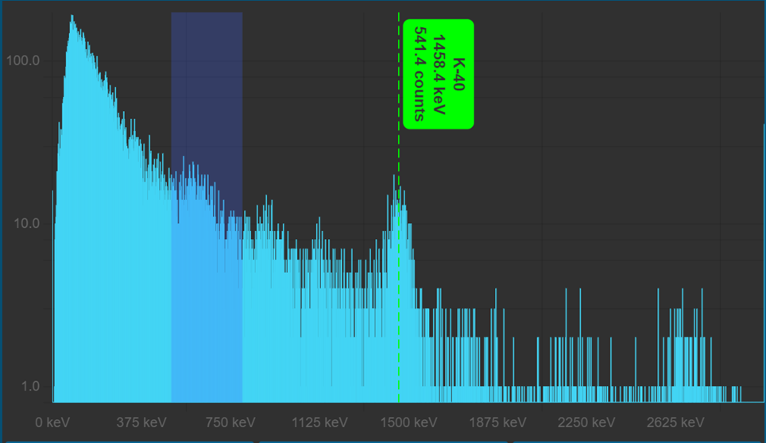

ALARM THRESHOLD SETUP
NOTE |  |  | - Take ICR from background measurement  - Calculate a “sigma” estimation (Square root of ICR)  - Set warning threshold: ICR background + 3/10/20*sigma  - Set Alarm threshold: ICR background + 5/20/50*sigma  - Expose the mobile to 1 or more source and see what happen  - Fill the note section with notes and considerations
ICR (cps) |  |  | 2.685
SIGMA (cps) |  |  | 0.127
WARNING (cps) |  |  | 0.057
ALARM (cps) |  |  | 0.000
NOTES

INVESTIGATION AND OPERATION MODE
NOTE |  |  | - Operation and Investigation modes  - Go in the setting and set the Operation mode  - Start a mission and name it “Operation mode test”  - Expose to Am-241 for 10 seconds  - Remove all sources for 10 seconds  - Expose to Cs-137 for 10 seconds  - Remove all sources for 10 seconds  - Expose to Co-60 for 10 seconds  - Remove all sources for 10 seconds  - Stop the mission and download the report  - Fill the note section with notes and considerations  - Go in the setting and set Investigation mode  - Repeat the above procedure  - Fill the note section with notes and considerations  - Analyse the differences between the two reports and make your considerations
NOTES

IDENTIFICATION CHECK
RADIATION MEASUREMENT CHECK
SOURCE | ACTIVITY |  |  |  | REF. DATE |  | DISTANCE
Co-57 | 9.20 uCi |  |  |  | 21/9/2023 |  | 40 cm
ICR (cps) |  |  | 5.353
SPECTROSCOPIC DOSE RATE (µSv/h) |  |  | 0.072
NEUTRON COUNT RATE (cps) |  |  | 0.000
SPECTRUM
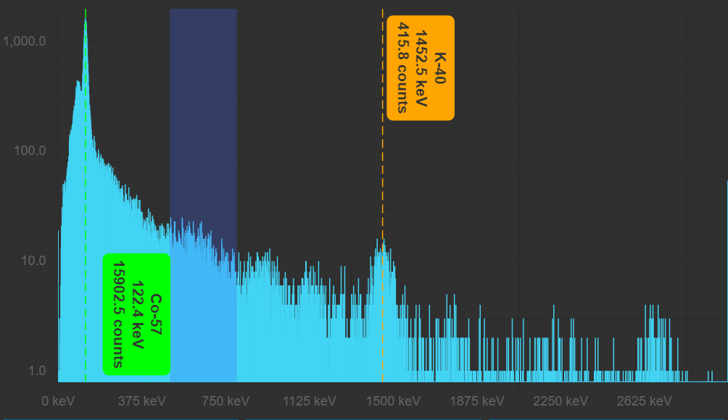

RADIATION MEASUREMENT CHECK
SOURCE | ACTIVITY |  | REF. DATE | DISTANCE
Cs-137 | 9.49 uCi |  | 5/8/2022 | 40 cm
ICR (cps) |  | 8.083
SPECTROSCOPIC DOSE RATE (µSv/h) |  | 0.198
NEUTRON COUNT RATE (cps) |  | 0.200
SPECTRUM
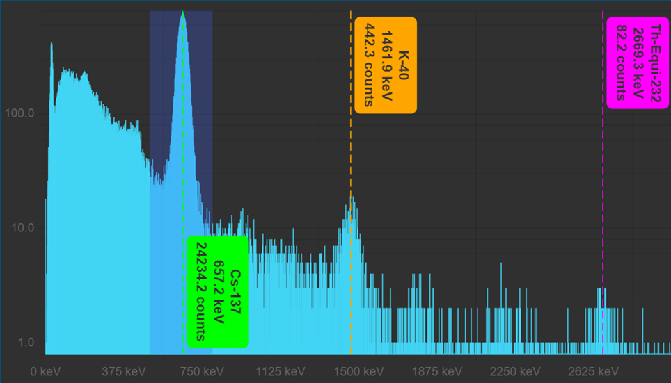

RADIATION MEASUREMENT CHECK
SOURCE | ACTIVITY |  | REF. DATE | DISTANCE
Am-241 | 10.8 uCi |  | 15/6/2022 | 40 cm
ICR (cps) |  | 5.754
SPECTROSCOPIC DOSE RATE (µSv/h) |  | 0.067
NEUTRON COUNT RATE (cps) |  | 0.000
SPECTRUM
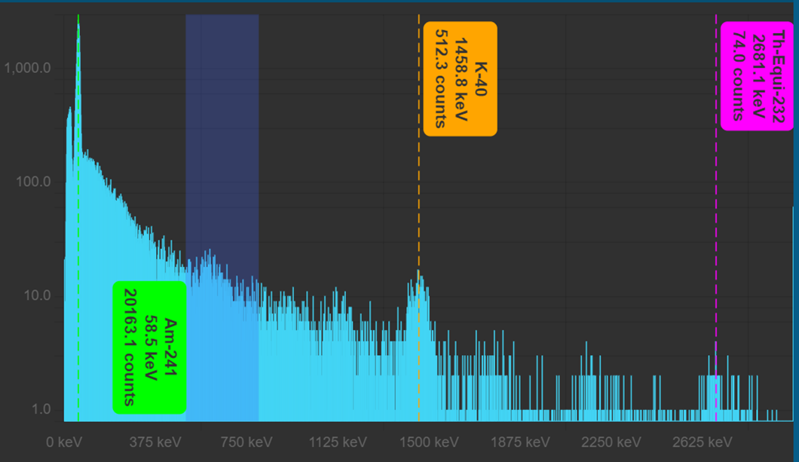

RADIATION MEASUREMENT CHECK
SOURCE | ACTIVITY |  | REF. DATE | DISTANCE
Co-57 | 9.20 uCi |  | 21/9/2023 | 40 cm
Co-60 | 1.00 uCi |  | 15/5/2013 | 10 cm
Cs-137 | 9.49 uCi |  | 5/8/2022 | 40 cm
Am-241 | 10.8 uCi |  | 15/6/2022 | 40 cm
ICR (cps) |  | 14.697
SPECTROSCOPIC DOSE RATE (µSv/h) |  | 0.294
NEUTRON COUNT RATE (cps) |  | 0.000
SPECTRUM
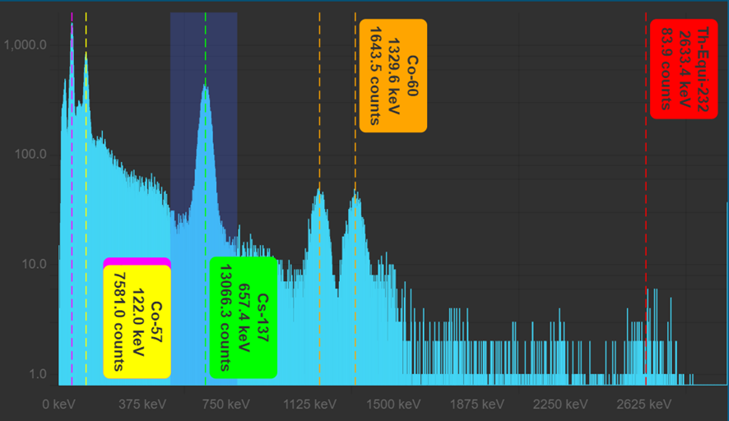

put warning and alarm threshold on all the mobiles on the best value following the round table consideration

edit the nuclide library following the standard and the best consideration

switch off everything and put tablet and mobile under charge before leaving the room

